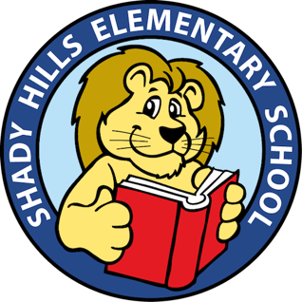
SHES Digital Learning Technical Support

Technical Support is available to you.
If you are in need of technical support, please use one of the following methods below-

- Go the the SHES website at shes.pasco.k12.fl.us to access the several Quick Guides for how-to/step-by-step information along with the Parent eLearning Newsletters or go to pasco.k12.fl.us for additional info/resources.
- Contact your child’s teacher(s). The SHES website has a tab called “Contact Us.” Email your teacher!
- Call SHES at 727-774-4100. Our office hours are Monday-Friday from 7:30-3:30. Our secretary will try to assist you or will have someone get back to you. Do NOT show up to our campus- as we’re closed.
- You could also email our Resource Management Associate- Jen Couchman at jcouchman@pasco.k12.fl.us.

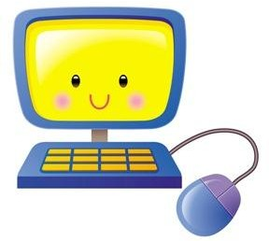
The expectation is that someone gets back to you as quickly as possible, within 24 hours (Monday-Friday).

When calling or emailing, please include the following information-
Your name
Your child(ren)’s name Your teacher’s name Your phone number
A detail explanation of the issue you’re having.

